**Q1: Create 1D, 2D and 3D model for the cantilever beam(Note: Set “Geometry property” to 3D analysis for all types)**

* 1 D model :

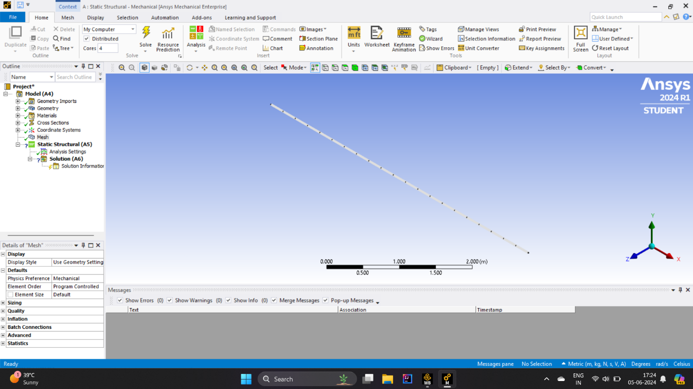

* 2 D model :

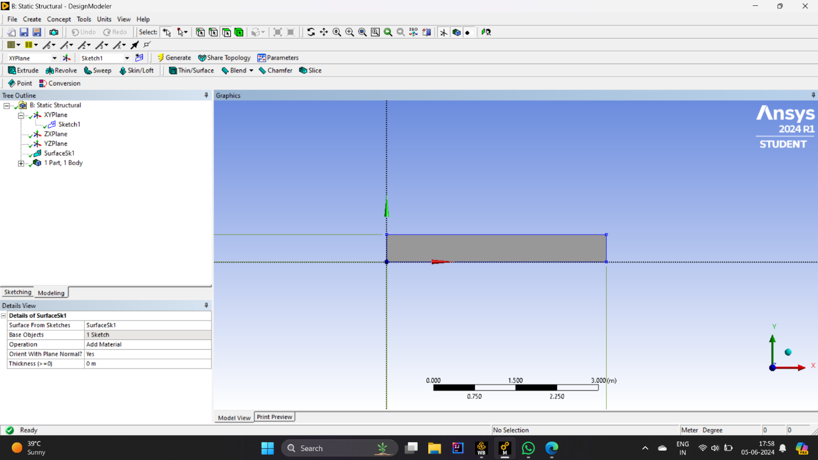

* 3 D model :

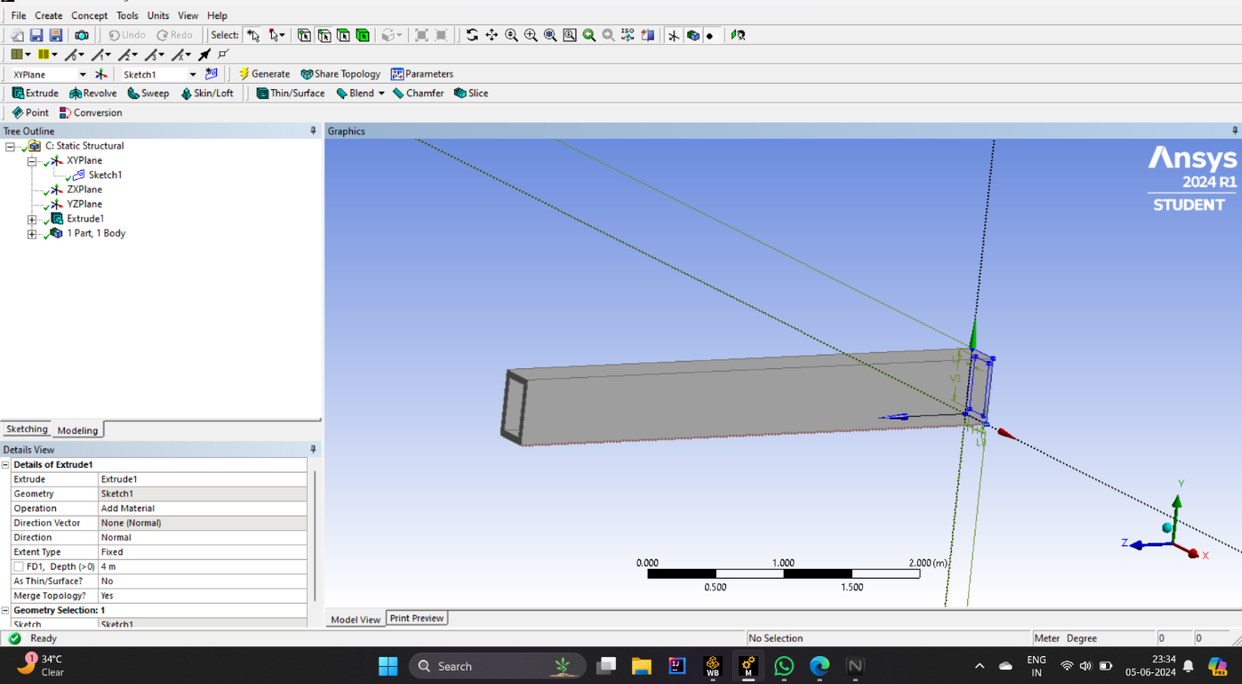

**Q2: Create applicable cross-section in 1D analysis and thickness in 2D analysis.**

* Cross section of 1 D model :

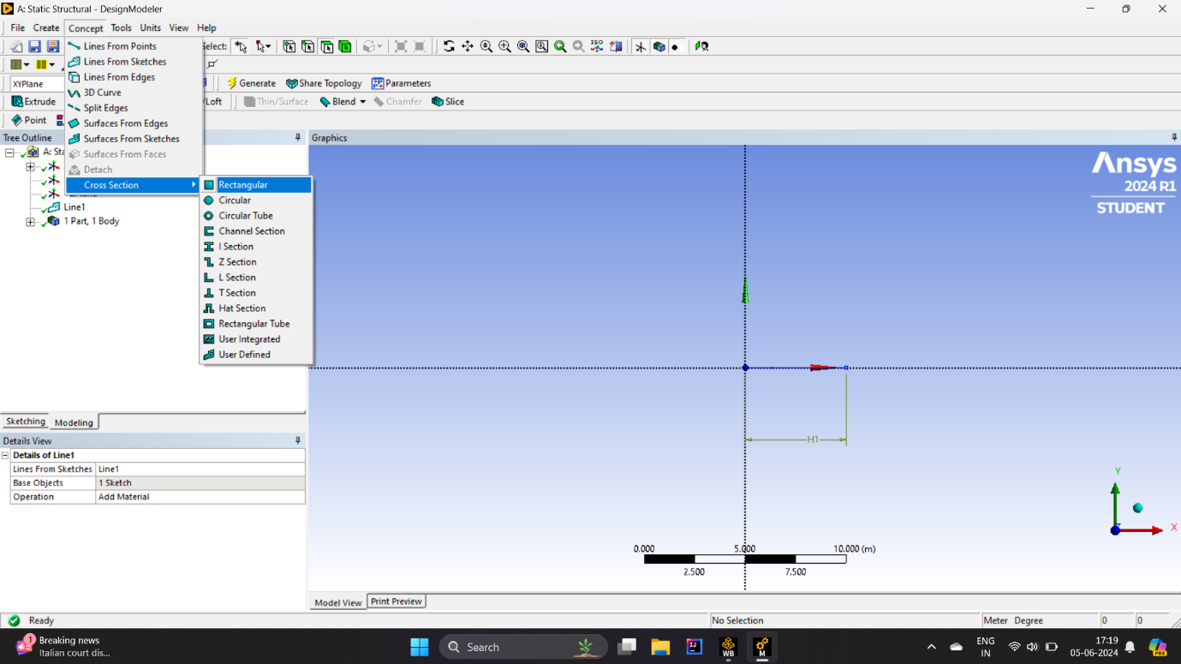

* Thickness in 2D model is 0.05m :



**Q3: Apply relevant boundary conditions and forces :**

Applied force on beam is 1 k/N .

This are force applied on 1d , 2d and 3d model .

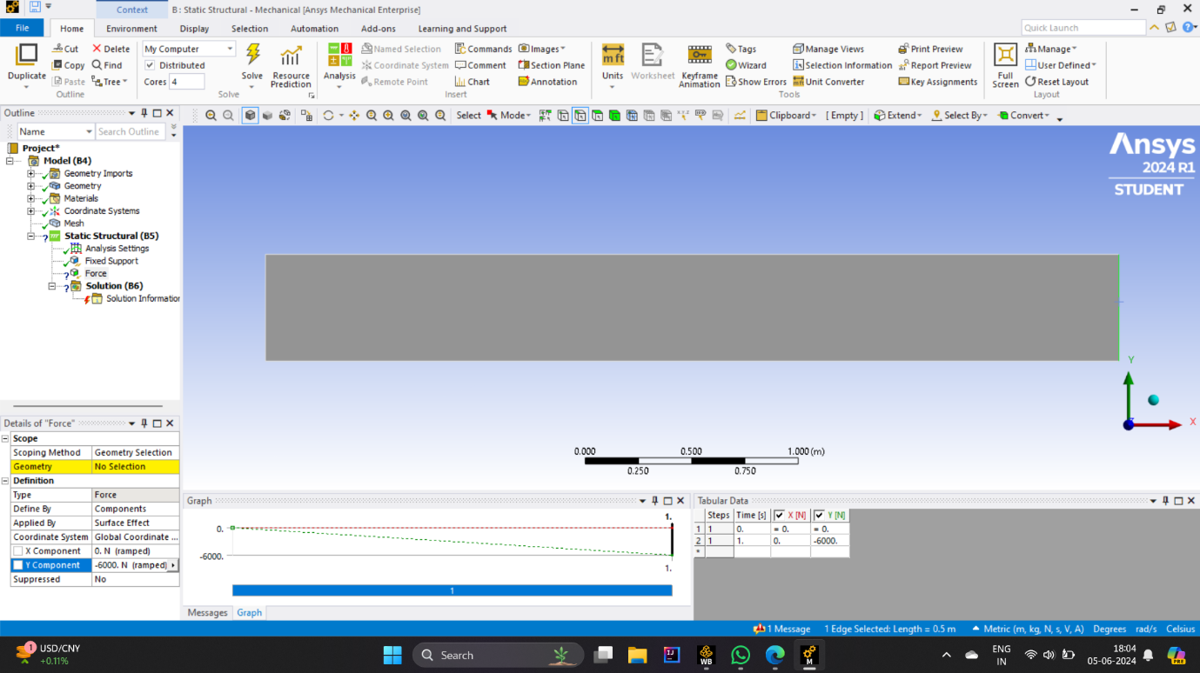

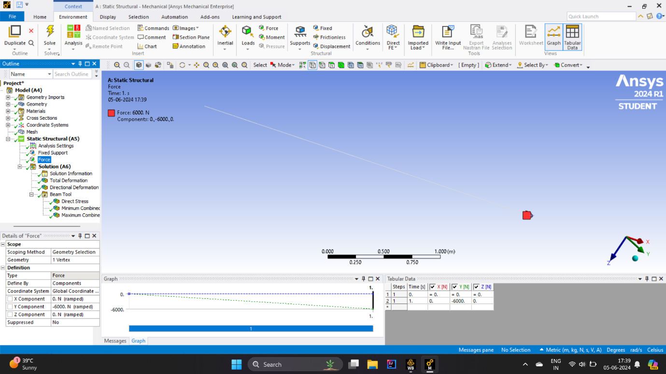

**Q4: Solve 1D, 2D and 3D problems and obtain total displacement of the beam.**

* Total displacement on 1D :

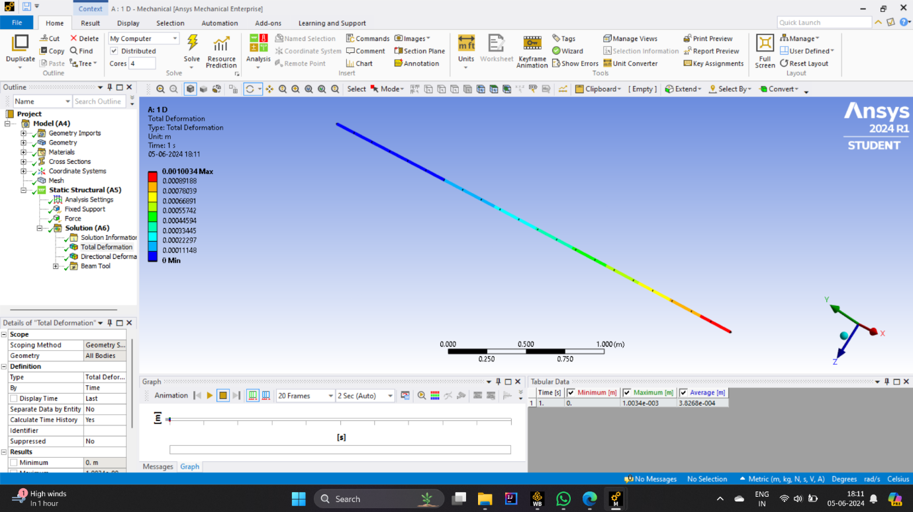

* Total displacement on 2D :

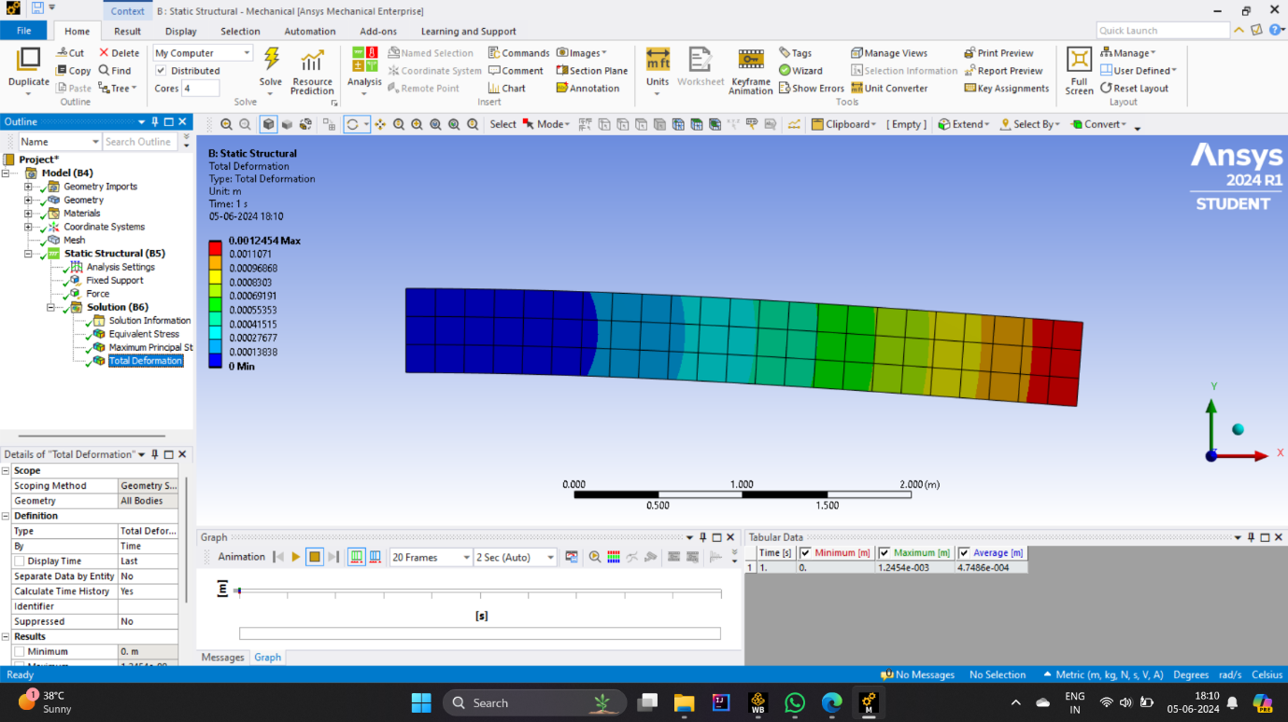

* Total displacement on 3D :

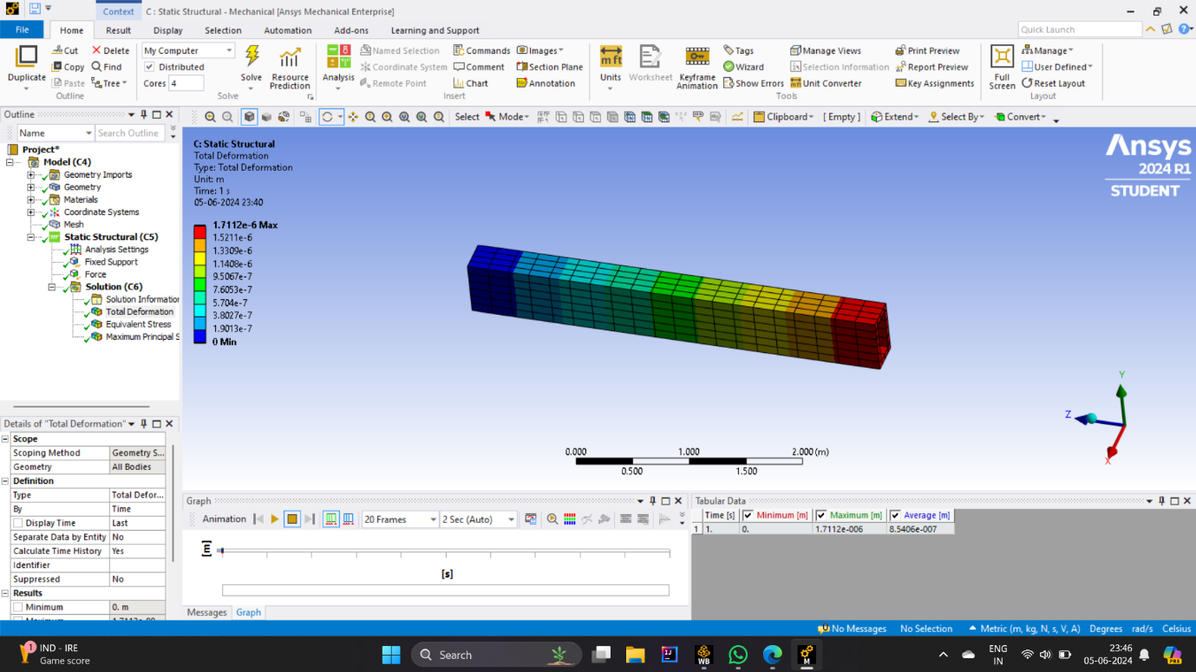

**Q5: Solve 1D, 2D and 3D problems and obtain Maximum stress and equivalent stress.**

* Maximum stress and equivalent stress of 1D :

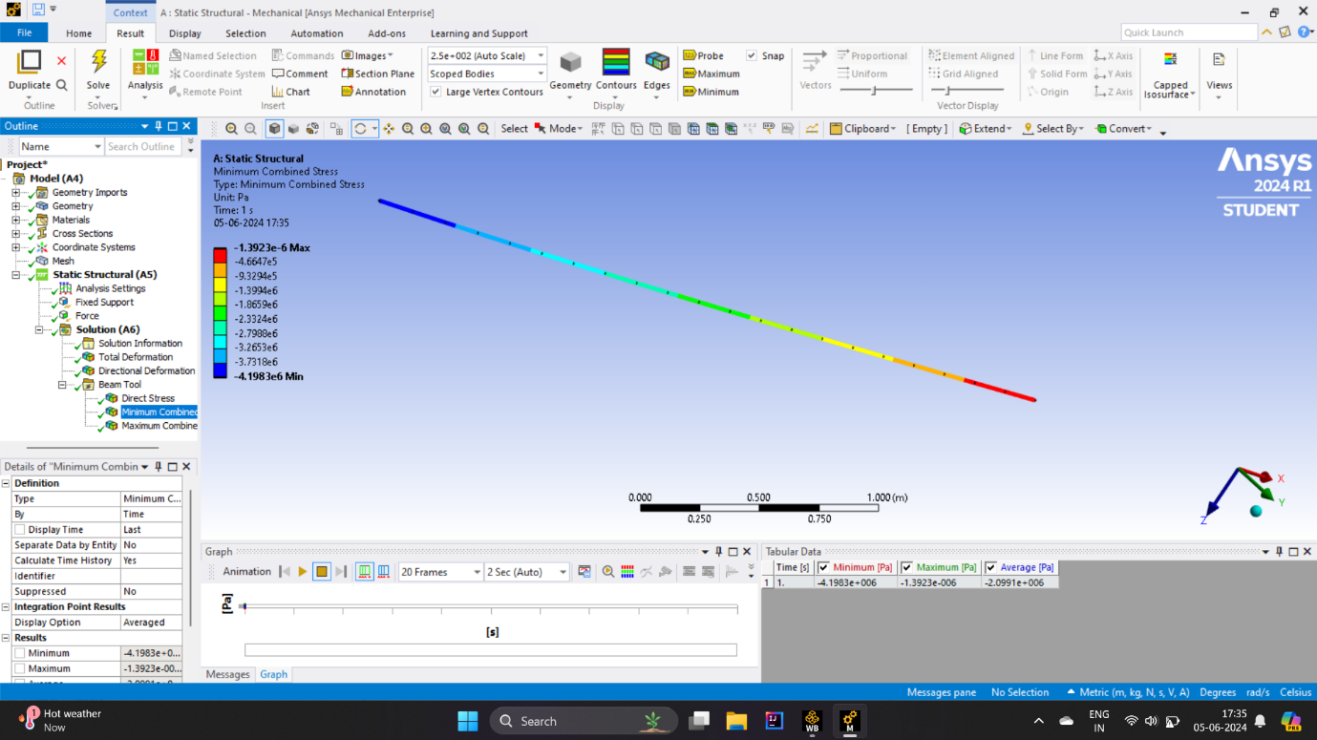

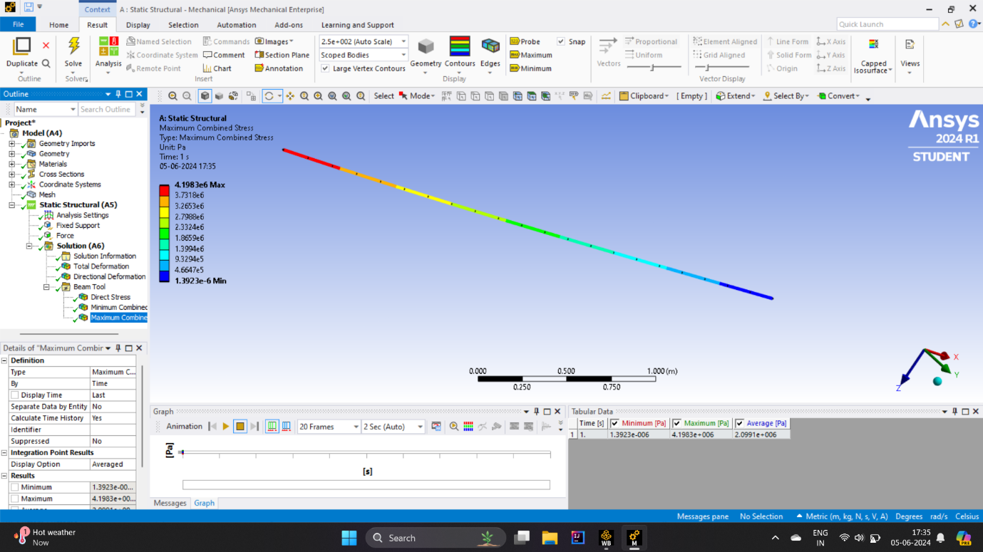

* Maximum stress and equivalent stress of 2D :

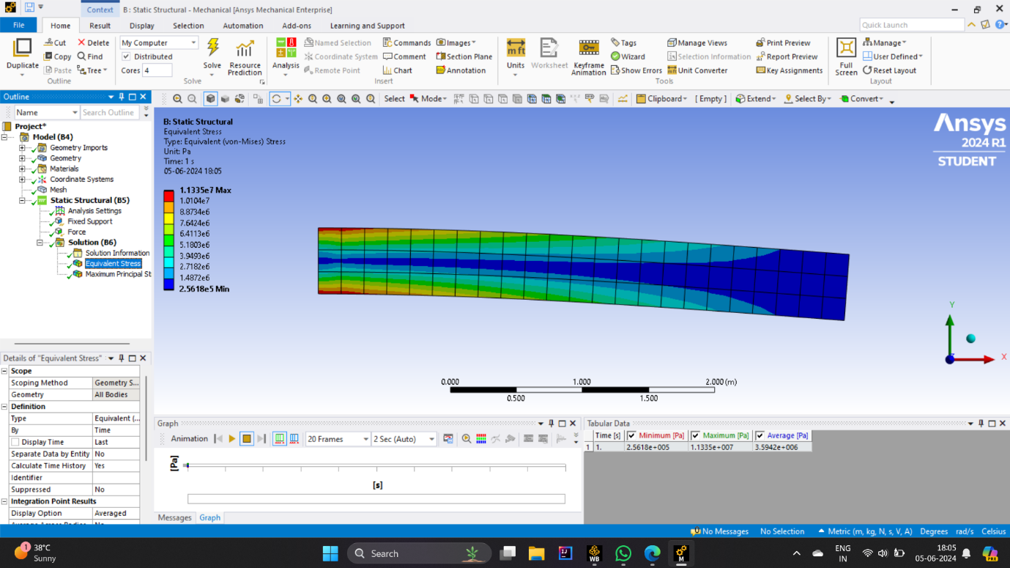

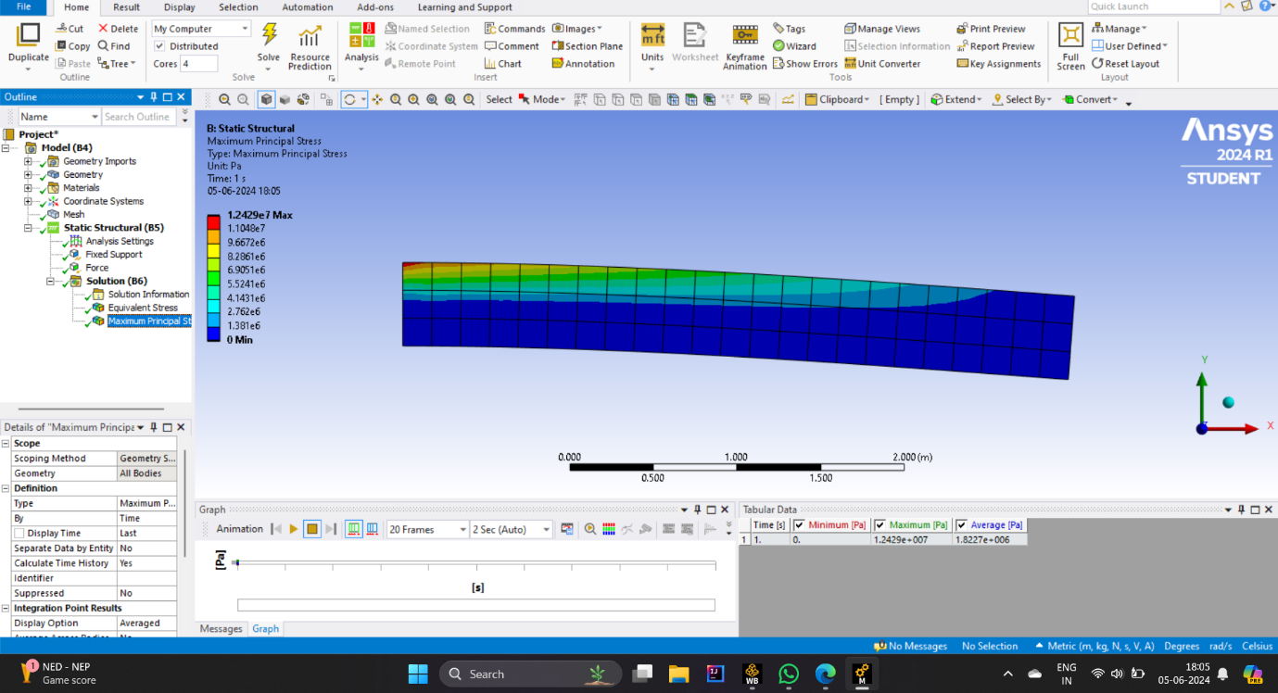

* Maximum stress and equivalent stress of 3D :

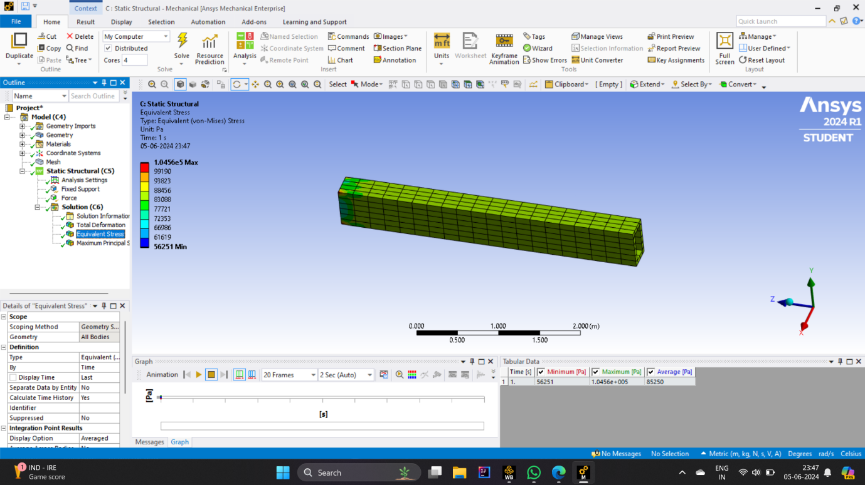

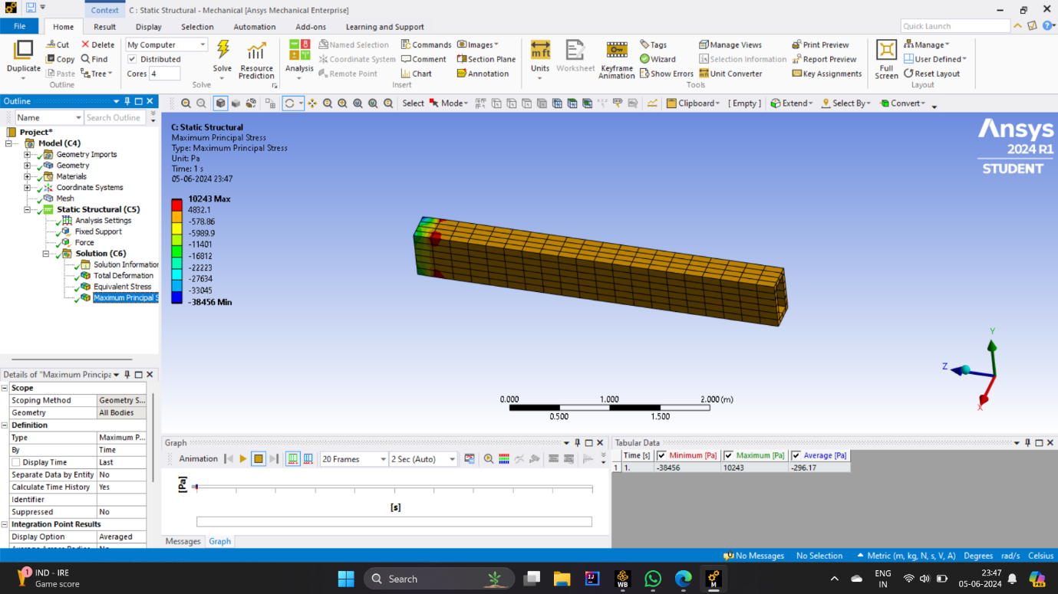

**Q6: Perform modal analysis on 1D, 2D and 3D problems and find first 10 natural frequencies for each case.**

* This are the first 10 natural frequency of 1D model :

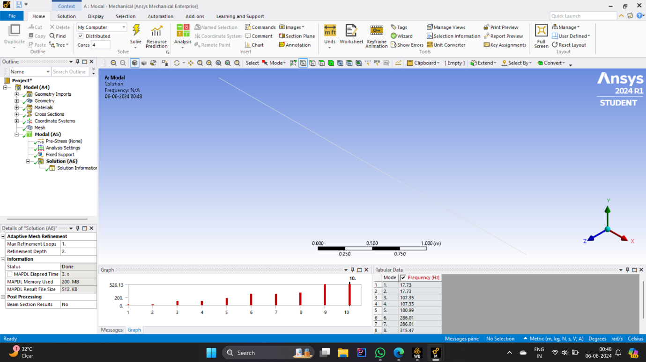

* This are the first 10 natural frequency of 2D model :

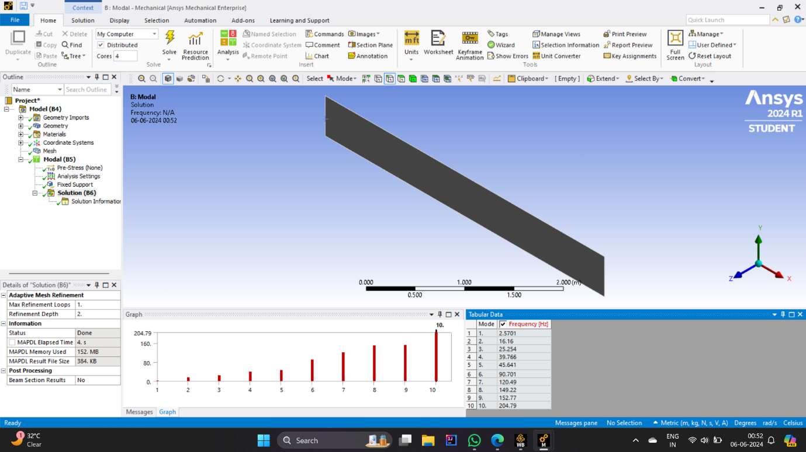

* This are the first 10 natural frequency of 3D model :

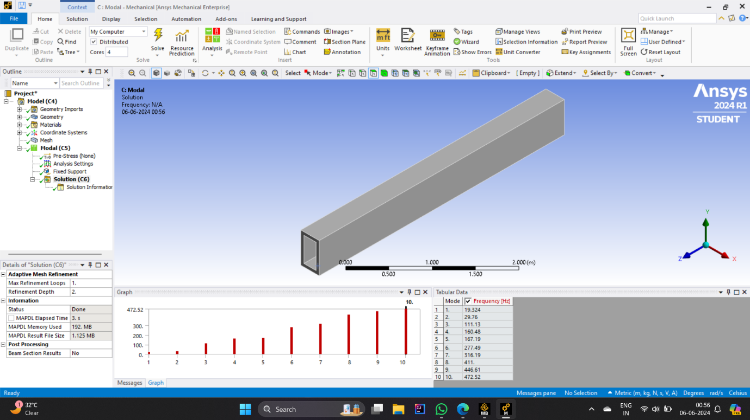

**Q7: Perform result analysis, result comparison and result discussion .**

* Definitions and Characteristics:

1D beam: A 1-dimensional beam is usually modeled using simple beam theory (Euler-Bernoulli beam theory). It considers bending in one plane and length characteristics.

2D Beam: A 2-dimensional beam can bend in two planes, resulting in additional vibration characteristics compared to a 1D beam. It considers leaning into and out of aircraft.

3D Beam: A 3-dimensional beam can bend in all three planes and includes torsional effects. This model considers a complex interaction of bending, torsion, and sometimes axial deformation.

* Natural frequencies:

The natural frequency of a beam depends on its geometry, physical properties, boundary conditions, and fold size.

As the intensity of the beam increases (from 1D to 3D), the number of possible vibration modes increases, resulting in finer natural frequencies

* comparison:

1D Ray:

The simplest model, usually only considers the original bending characteristics.

In general, 2D and 3D light have lower natural frequencies compared to each other because there are fewer modes.

2D Ray:

New bending modes resulting in higher natural frequencies compared to 1D beams have been added.

In-plane and out-of-plane deflections produce more complex vibrations.

3D Beam:

The most complex model, incorporates bending and twisting in three directions.

The highest natural frequencies of the three due to high vibrational modes and interactions.

It is capable of capturing all possible vibration effects including torsion affecting a large natural frequency.

* Results Discussion:

Frequency range: As dimensional complexity increases, the frequency range becomes wider. A 3D beam will exhibit a wider frequency range than a 1D beam.

Mode Shapes: As we move from 1D to 3D beams, mode shapes become more complex and go in many different directions. A 3D beam will show coupling between bending modes that is not captured in 1D or 2D models.

Practical implications: Beam model selection affects the design and analysis of structures. For simple systems where high accuracy is not a priority, a 1D model may suffice. However, for complex structures, especially those subjected to dynamic loads, 3D models provide an accurate representation of biological behavior.

* conclusion:

In summary, when transitioning from a 1D to a 3D beam model, we find that the natural frequency increases and the folding is complicated. This variation allows a detailed understanding of the dynamic behavior of the beam, which is essential for accurate analysis and design in industrial applications but comes at the cost of complex computation and modeling effort a it goes up to the top.

**References :**

* Bathe, K. J. (2006). Finite element procedures. Klaus-Jurgen Bathe.
* Cook, R. D., Malkus, D. S., Plesha, M. E., & Witt, R. J. (2002). Concepts and applications of finite element analysis (4th ed.). Wiley.
* Hughes, T. J. R. (2000). The finite element method: Linear static and dynamic finite element analysis. Dover Publications.
* Logan, D. L. (2011). A first course in the finite element method (5th ed.). Cengage Learning.
* Zienkiewicz, O. C., & Taylor, R. L. (2000). The finite element method: Volume 1, The basis (5th ed.). Butterworth-Heinemann.
* Reddy, J. N. (2006). An introduction to the finite element method (3rd ed.). McGraw-Hill.
* Boresi, A. P., Schmidt, R. J., & Sidebottom, O. M. (1993). Advanced mechanics of materials (5th ed.). Wiley.
* Dowling, N. E. (2013). Mechanical behavior of materials: Engineering methods for deformation, fracture, and fatigue (4th ed.). Pearson.
* Hibbeler, R. C. (2017). Mechanics of materials (10th ed.). Pearson.
* Juvinall, R. C., & Marshek, K. M. (2012). Fundamentals of machine component design (5th ed.). Wiley.